# CS 255 System Design Document Template

## UML Diagrams

### UML Use Case Diagram

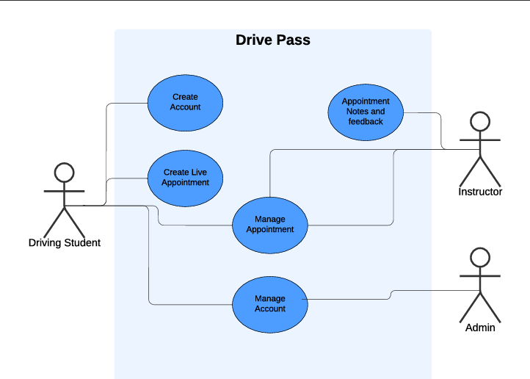

### UML Activity Diagrams

User Creates Appointment:

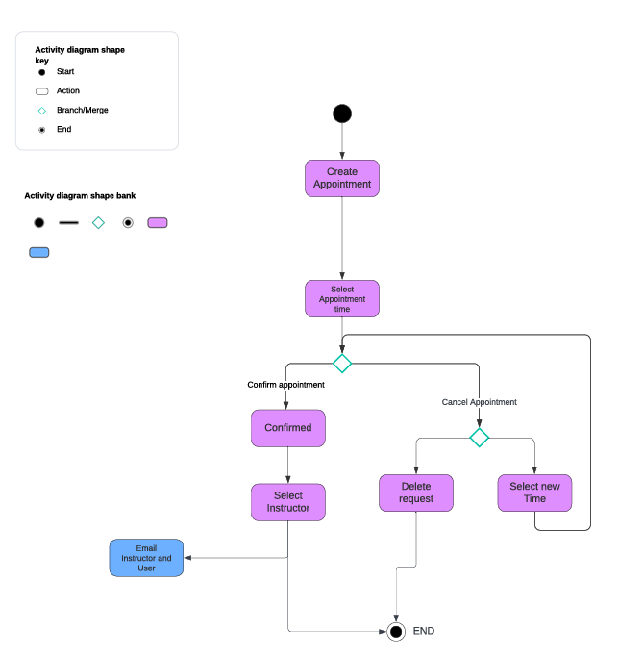

User creates account:

### UML Sequence Diagram

### UML Class Diagram

## Technical Requirements

This system will require it to be hosted on cloud-based infrastructure and accessible online from any type of mobile device. This server which hosts this system will require the ability to be expanded on moment’s notice to ensure growth is easily adaptable. It will require the ability to email, so an automatic email confirmation can be established for the students and instructors based on appointments. For the software, we are looking at an operating system of the server to host this system, MySQL or PostgreSQL to store and manage all the data that is collected to ensure things can be changed and remain changed. As well as user database management, and appointment management. We will need a web application, it will need to be built on a language like ruby, and a web server for http requests. We will also need security systems and policy established so our staff and instructors know how to handle their data, and the data collected from users to ensure privacy. We need to ensure user and all data from the apps are kept in a secure environment and withing secured data storage. This can use encryption and regular security audits conducted. We will also need a method and applications for continuously updating the website and backend systems. This could be something like Visual Studio, or a web service like GitHub. The last two requirements would be staff training and technical documentation is kept about every part of the system to support staff and users.